Mauritius

## Population Data

The data set shows the political stability estimate of the country each year.

## # A tibble: 23 x 5  
## country iso3c date population popCategory5  
## <chr> <chr> <dbl> <dbl> <chr>   
## 1 Mauritius MUS 1996 1133996 very small   
## 2 Mauritius MUS 1997 1148284 very small   
## 3 Mauritius MUS 1998 1160421 very small   
## 4 Mauritius MUS 1999 1175267 very small   
## 5 Mauritius MUS 2000 1186873 very small   
## 6 Mauritius MUS 2001 1196287 very small   
## 7 Mauritius MUS 2002 1204621 very small   
## 8 Mauritius MUS 2003 1213370 very small   
## 9 Mauritius MUS 2004 1221003 very small   
## 10 Mauritius MUS 2005 1228254 very small   
## 11 Mauritius MUS 2006 1233996 very small   
## 12 Mauritius MUS 2007 1239630 very small   
## 13 Mauritius MUS 2008 1244121 very small   
## 14 Mauritius MUS 2009 1247429 very small   
## 15 Mauritius MUS 2010 1250400 very small   
## 16 Mauritius MUS 2011 1252404 very small   
## 17 Mauritius MUS 2012 1255882 very small   
## 18 Mauritius MUS 2013 1258653 very small   
## 19 Mauritius MUS 2014 1260934 very small   
## 20 Mauritius MUS 2015 1262605 very small   
## 21 Mauritius MUS 2016 1263473 very small   
## 22 Mauritius MUS 2017 1264613 very small   
## 23 Mauritius MUS 2018 1265303 very small

# Population growth data

## # A tibble: 23 x 5  
## country iso3c date popGrowth popGrowthCat5   
## <chr> <chr> <dbl> <dbl> <chr>   
## 1 Mauritius MUS 1996 1.02 slow growth rate  
## 2 Mauritius MUS 1997 1.25 slow growth rate  
## 3 Mauritius MUS 1998 1.05 slow growth rate  
## 4 Mauritius MUS 1999 1.27 slow growth rate  
## 5 Mauritius MUS 2000 0.983 slow growth rate  
## 6 Mauritius MUS 2001 0.790 slow growth rate  
## 7 Mauritius MUS 2002 0.694 slow growth rate  
## 8 Mauritius MUS 2003 0.724 slow growth rate  
## 9 Mauritius MUS 2004 0.627 slow growth rate  
## 10 Mauritius MUS 2005 0.592 slow growth rate  
## 11 Mauritius MUS 2006 0.466 slow growth rate  
## 12 Mauritius MUS 2007 0.456 slow growth rate  
## 13 Mauritius MUS 2008 0.362 slow growth rate  
## 14 Mauritius MUS 2009 0.266 slow growth rate  
## 15 Mauritius MUS 2010 0.238 slow growth rate  
## 16 Mauritius MUS 2011 0.160 slow growth rate  
## 17 Mauritius MUS 2012 0.277 slow growth rate  
## 18 Mauritius MUS 2013 0.220 slow growth rate  
## 19 Mauritius MUS 2014 0.181 slow growth rate  
## 20 Mauritius MUS 2015 0.132 slow growth rate  
## 21 Mauritius MUS 2016 0.0687 slow growth rate  
## 22 Mauritius MUS 2017 0.0902 slow growth rate  
## 23 Mauritius MUS 2018 0.0545 slow growth rate

## Population trend

The plot shows the population trend of the country.

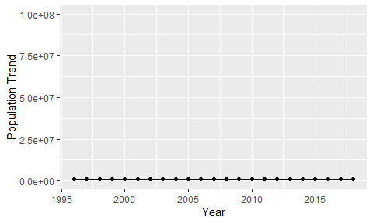

Political Stability Trend

# Population growth trend

The plot shows the population growth rate trend of the country.

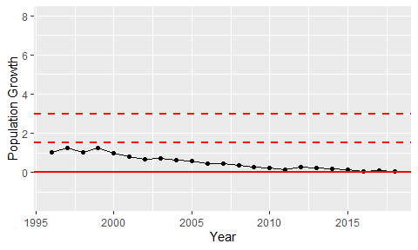

Population Growth Trend